CSI2441 Applications Development – Assignment One

Coding logic design and implementation (15 Marks Total)
Your first assignment will require you to develop a record processing system in both ASP and PHP, giving you an opportunity to see two modern web scripting languages in action. You will be provided with an input form for both ASP and PHP, from which you must develop a logically design script which validates and processes the incoming data, presenting the results to screen. Your use of Functions, Control Structures, Input Validation, Conditions, and basic numerical calculations will form the core of each ASP/PHP script.

Task
Your task is to create an ASP and PHP page that reads in the data from the attached forms, validate the data (looking for physical and logical errors), then process the data and output a summary. Your script is required to process a list of units in order to help students figure out how much of their course they have completed and how far they have to go in terms of credit points (CP) and semesters.

The following screenshot shows some of the fields in the input form you have been provided with;

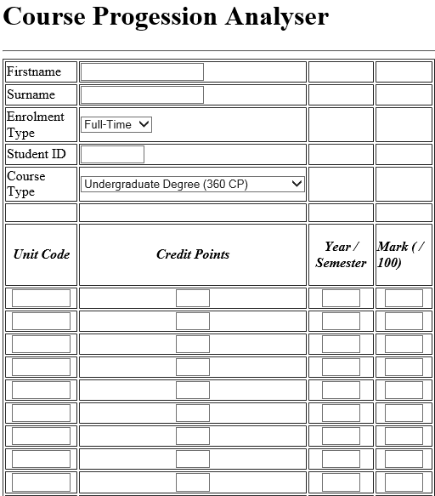

The first three fields simply identify the student, while the Enrolment Type specifies if the student is studying full time or part time. The Course Type field asks the student to choose the type of degree they are studying (which dictates the credit points required for completion). After this is 30 rows of records, each recording a unitcode, the credit points that unit is worth (15 or 20), the semester it was studied (Semester 2, 2015 would be 152) and the mark received for the unit. The reason for 30 fields instead of a maximum of 24 is that a student may not have passed all units on the first attempt.

Your job is to write each of your scripts according to the following business logic;

All units that have a mark of 50 or higher have their Credit Points added to a grand total, this total then being subtracted from the Credit Points required for each of the five listed course types. The total credit points required for each degree is;

Undergraduate - 360
Undergraduate Double Degree - 480
Graduate Diploma - 120
Masters by Coursework - 180
Masters by Research - 240

Thus, if a student fills in 10 rows on the form with units, each unit being worth 15 Credit Points, but has only passed 8 of those units, then the Total Passed Credit Points will be 120, leaving 240 Credit Points Required if they are studying an Undergraduate degree.

Your job is to develop core functionality that will output the Total Passed Credit Points, the Credit Points Required, Semesters Required along with the students name, student ID and Course Type. You need to also indicate how many units have been attempted and how many have been successfully completed, as well as the student’s course average (indicated as a mark and a grade, such as 65 Cr).
Based on the students Enrolment Type (full time or part time) you need to also indicate how many semesters study remain based on 30 CP per semester for part time students and 60 CP for full time students. If the student has obtained or gone over their required Credit Points for their course a Course Completed indicator needs to appear on screen.

Some of the advanced criteria include required in the assignment include;
- If a student fails the same unit 3 times, their course status is to be displayed as Excluded from Course
- A unit cannot appear as Passed (ie with a Mark of 50 or higher) more than once
- A unit code cannot appear more than once in the same semester
- If a student does more than one unit in a given semester (ie between 2 and 4), and fails only one unit with a mark in the range of 45-49, and is in the first or last semester of their course then the Grade for that unit should read as S? (for possible Supp assessment). This is a tricky one, as the Enrolment Type will dictate the number of CP to be studied in a given semester.
- Which unit did the student receive the highest mark for during their course?

It is suggested that these advanced criteria be tackled once the core functionality has been implemented.

The minimum validation you need to perform includes;

- None of the input fields (rows with data) have blank fields. This means then entire row is filled, or it is entirely blank - and blank rows are ignored
- The Unitcode data is not less than 7 characters in length and is 3 uppercase letters followed by 4 numbers
- That the Credit Points field contains only 15 or 20, nothing else
- That the Year/Semester field contains only 3 digits
- That the Mark field is numeric, and not less than zero or greater than 100
- The student id field is numeric and not less than 8 characters in length
- Students studying any undergraduate course cannot be enrolled in a unitcode of 6000 level (ie CSG6204)
- Validation / error messages and course Summary Outputs should be on the same screen - it should be one or the other, not both.

NOTE: students MUST NOT alter the forms that you have been provided with – your task is to write code that deals with the input from these forms as-is. Forms that have been altered will not be marked.

Assignment Submission
When you have completed your assignment, you need to load ALL your files into Blackboard on or before the submission date. It is best to zip your site (with your student id and unit code as part of the filename) and then submit that file into Blackboard.

Remember, all files will be checked against all others from this semester and previous semesters, so do not share your work with others or use other student work as this can lead to issues of collusion and loss of marks.

CSI2441 Assignment 1: Marking Key

Coding (15 Marks)
Criteria | Mark Weighting
All Validation Correct | / 3
Modularisation and Code Commenting | / 3
Correct Summary Output (Credit Points / Course Avg / Semesters Remaining / Units Passed / Failed) | / 6
Implementation of Advanced Criteria | / 3

Overall Summary
Total Mark __ / 15
Assignment Grade _____
* Please note that submission of only one coded environment (ASP or PHP) will mean marking will automatically be
halved.

